DVD Rip Tutorial by EJ

Table of contents

Subjects
Intro
Required programs:
System requirements:
Copying the main movie files to your H.D.
Finding out the length of the movie

Calculating Audio & Video Bitrates:
Flask Mpeg DeCSS 0.594:
Flask MPEG 0.6-Extracting the audio
Sound Forge 4.5 or higher- Fixing the audio
Virtual Dub

Intro: After I've watched those 14-fps-low-resultion movies I downloaded from the internet I decided to write my own DVD rip tutorial for all the lame rippers out there!!!
It took me a lot of time to understand how to produce high-quality rips.
I've tried a lot of softwares, so use what I'm telling you to use because I probably
know better than you!
I added a lot of screen shots so in case you'll have problems you'll know what to do…
And now LET'S RIP!

Required programs:
1.DVD Decrypter 2.4 or higher http://www.digital-digest.com or http://www.flexion.org
2.Power DVD 3 or higher or any DVD player with a timeline http://www.cyberlink.com or http://www.digital-digest.com
3.Ecuador's AVI Bitrate Calculator 2 http://www.digital-digest.com or http://www.geocities.com/ecuador_gr
4.Divx 3.11 Codec http://www.divx.com
5.FlasK MPEG 0.594+Subtitle fix (EXE) and FlasK MPEG 0.6 (both!!)+ Thunder Mism addon (thunder.mism.flask).
You can download them at http://www.flaskmpeg.net and if you won't find something go to: http://www.digital-digest.com
6.Sonic Foundry Sound Forge 4.5 or higher http://www.sonicfoundry.com
7.Virtual Dub 1.4b or higher at http://www.digital-digest.com or http://www186.pair.com/vdub/index.html

System requirements:
1.Pentium 3 or AMD (450 Mhz or faster)
2.H.D space: *probably 4-8 GB for the DVD movie
*about 500-580 MB for the compressed video (without audio)
*about 1 GB (no more than 2 GB) for the extracted audio
*up to 700 MB for the compressed video (with audio)
3.RAM: recommended at least 64 MB, - the more the better
4.DVD Drive- its speed will determine the DVD copy time.
5.CD Burner recommended

Copying the main movie files to your H.D.

Our first goal is to copy the files from the DVD to the H.D.
This will help us to rip the movie faster.
To do so - insert the DVD into the DVD Drive and use DVD Decrypter to copy:
When you'll launch the DVD Decrypter it will automatically select the files you need.
If it won't, then go to Mode and select Normal and also go to Edit and select Select Main Movie Files.
Choose the wanted destination on your H.D (make sure you have the required space which is written on the right-lower edge of the program) and then press Decrypt.
The operation should take around 15 to 50 Minutes.
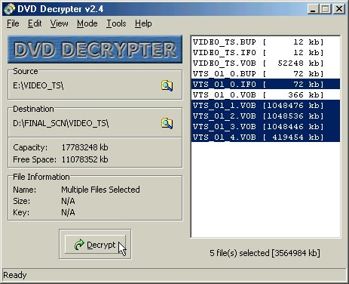
When you'll launch DVD Decrypter it will automatically select the files you need.
If it won't then go to Mode and select Normal and also go to Edit and select Select Main Movie Files.
Choose destination on your H.D (make sure you have the required space which written on the right-lower edge of the program and) then press Decrypt.
The operation should take about 15-50 Minutes.

Finding out the length of the movie
To do this, launch the Power DVD program, start playing the movie, then skip to the end of the movie, just a second before the credits starts:
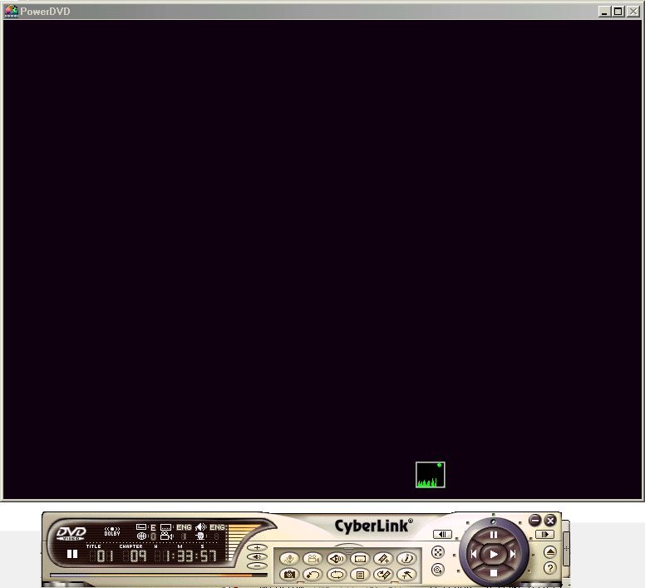
Then you'll see the movie length (we need the length in mins (for example 94 mins)).
You'll need the movie length for the next step, so it is advised to write it down.

Calculating Audio & Video Bitrates:
First, launch Ecuador's AVI Bitrate Calculator 2.
Choose the Video Bitrate Calc option.
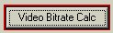
Now write the movie length in minutes (you got it from the Power DVD program),
Try to get about 910 kbps (and no more than 930. use less than 885 only if your movie is very long) at the Estimated Video Bitrate.
The Audio Bitrate should be from 64 kbps (for extremely long movies) and up to 112 (for shorter movies).
Change the CD Capacity up to 700 MB (or 650 if your burner isn't capable of writing more than 650 MB).
Adjust the Audio Bitrate and CD Capacity settings until you find the best result for you but don't forget the rules I've mentioned above.
Note: The movie size will not always be like the one you've set at the CD Capacity option, sometimes it'll be smaller (it happened to me) or bigger (It didn't happen yet and I'm not sure if it's possible).
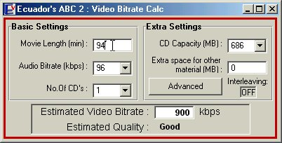
Write down the movie length, the Estimated Video Bitrate and the Audio Bitrate- you'll need these parameters later on!

Flask Mpeg DeCSS 0.594:
Now what we need to do is to compress the DVD files (Vob=video objects) and make it small enough so it can fit in a CD instead of 4-8 GB... approximately which is the VOBs size on the DVD.
We'll use the Divx 3.11 Codec.
Launch Flask Mpeg 0.594 Subtitle Fix (This EXE should be in the Flask Mpeg 0.594 folder)

Select File→Open DVD
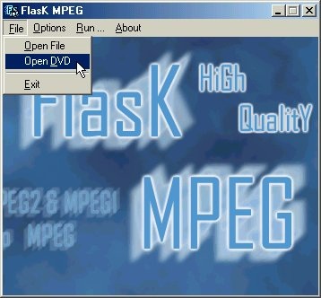

Go to the folder where to which you've copied the DVD Files, and open the IFO File.
It looks something like VTS_**_*.IFO.
(For example: VTS_01_0.IFO)

Now you'll see a new window opening, where you'll need to choose:
1.Duration- It should be approximately the movie length we previously talked about.
2.DVD Audio Tracks- Nevermind, we'll deal with the audio later, just write down the order of the Audio Tracks and the languages (e.g. English first, French second etc…)
3.DVD Subtitles-Your preferable language.
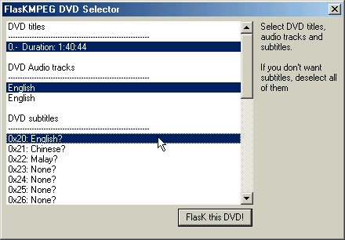

After you finish, click on FlasK this DVD!

Select Options→Global Project Options
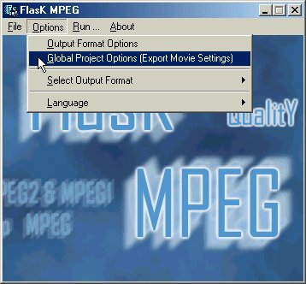

Now you need to change the settings:
Change the Time Base (fps) to 23.976 (Step 1,green arrow) and check the Reconstruct progressive images box (Step 2) and change again the Time Base to 25 if your DVD is from zone 2 (Step 3- zone 2) or to 29.97 if your DVD is from zone 1 (Step 3- zone 1).
Now press Show Output Pad (Step 4).

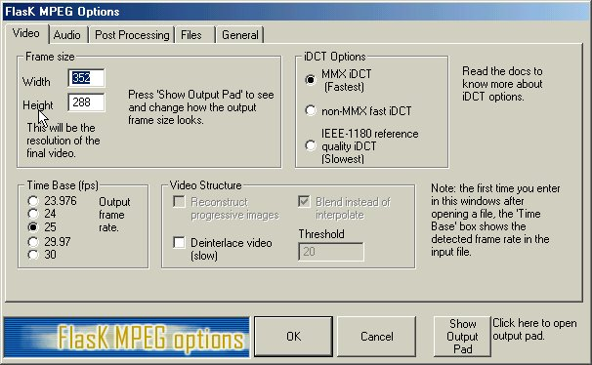
Step 1
Step 2
Step 3- zone 2
Step 3- zone 1
Step 4

Now we can see the FlasK MPEG Output Pad window.
Click on Reset settings (look at the following screen shot)
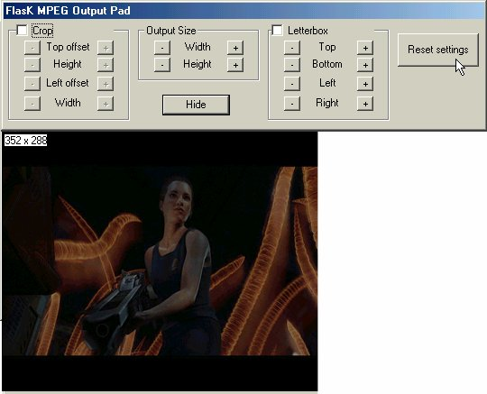

Our window is much bigger now because we see the original DVD resolution:
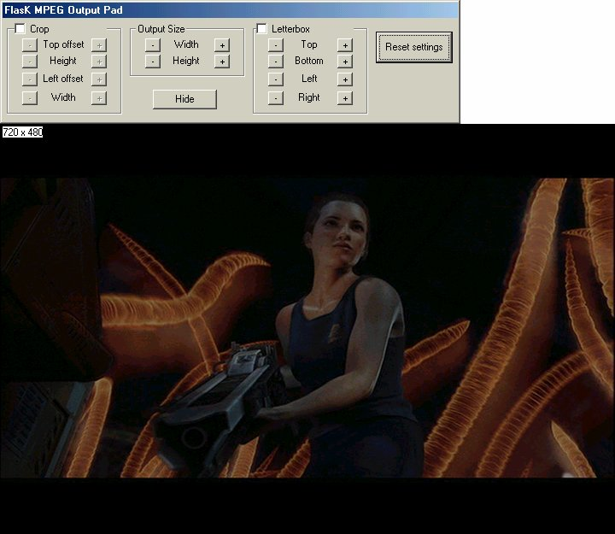

Our DVD movie is probably a widescreen or smaller than the original resoultion so we can reduce the resolution to a lower one which will contain only the movie without the top and bottom black frames.
This action is called "crop" and to do it we'll need to do the following:
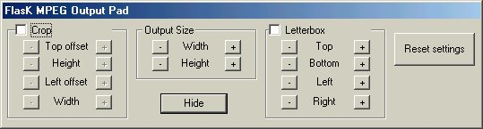

Check the Crop square.

Press the Height button a few times and then the Top offset button a few times.
Match your presses so you'll reduce the top and bottom black frames but leave a small top and bottom frame in order not to cut the movie itself!
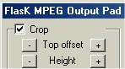

When you finish press Hide.

Go to the Audio tab and choose Don't process audio- we'll handle it later.
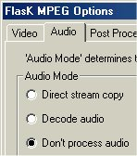

Go to the Files tab and browse to the directory where you want the video file to be saved.
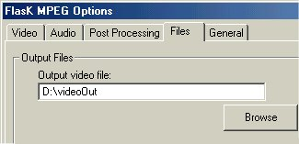

You may go to the General tab and check the Shut down option because it takes hours to rip (5-13 hours)
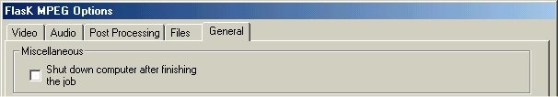
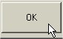

Now press the button.

Go to Options→ Output Format Options
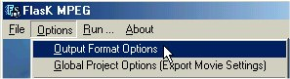

Press the video Select Codec (Step 1)
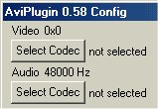
Step 1
Choose DivX ;-) MPEG-4 Fast-Motion (Step 1) and press Configure (Step 2).
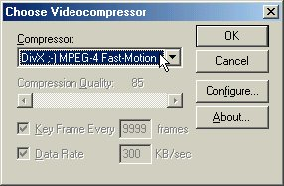
Step 1
Step 3
Step 2
Configure the Data Rate to the value you got at the Ecuador's AVI Bitrate Calculator 2 and press OK.
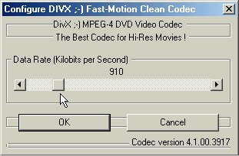

Press the audio Select Codec (Step 2)
Step 2
Configure to whatever you want, we don't handle the audio now so it doesn't matter.
Press OK until you get to the main Flask MPEG screen.
Now go to Run→Start Conversion.
Come back few hours later when it'll finish.
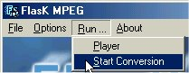

Flask MPEG 0.6-Extracting the audio
Now we need to extract the audio and for that we'll use the Flask MPEG 0.6 (preview or higher) program.
You need the Thunder Mism addon (thunder.mism.flask) in order to load the DVD movie IFO.

Go to File→Open Media
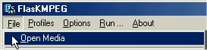

Go to the folder where you copied the DVD Files and open the IFO File.
It looks something like VTS_**_*.IFO (For example: VTS_01_0.IFO)
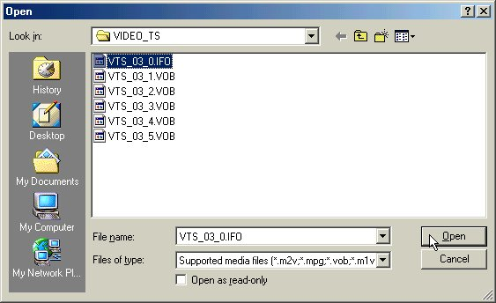

Choose the right DVD title- Choose the title which its time matches your DVD movie.
Choose the DVD audio track- If all the languages are similar, one of them should be in stereo instead of AC 3 or some commentary.
If you don't know what to choose we'll find it out in a few minutes.
Subtitles aren't necessary because we're interested only in the audio.
When you finish press FlasK this DVD!
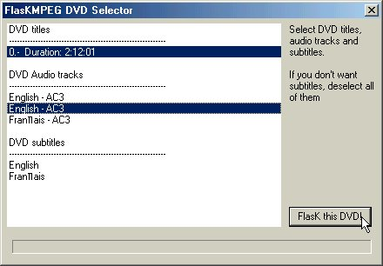

Now we'll find out which Audio Track we need.
(you can skip this phase if you only have one language, and you're sure it's the one you need.)
Click on Audio Player in the main Flask window.
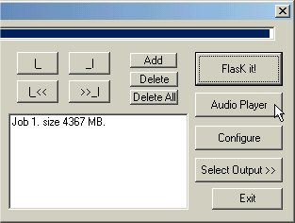
Change the audio track and play them one-by-one until you find the right one.
When you find it, remember its order (if it was first or second etc...)
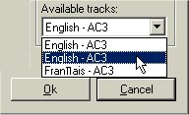
In my case the first audio tracks is the right one.
So now we'll re-open the DVD movie IFO file (like we previously did) and choose the right audio, I'll choose the first.

Then we'll go to Options→Global Project Options

Go to the Audio tab and choose Direct Stream copy
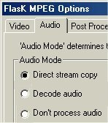
Go to the Files tab and browse to the location where you want the audio output file to be saved (it's a .wav) and press OK.
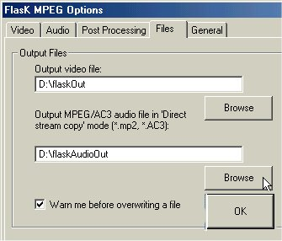

In the Flask main window choose Run→Extract Audio to .wav and wait.
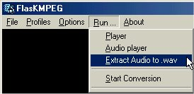

Sound Forge 4.5 or higher- Fixing the audio
Now that we've finished compressing the video and extracting the audio we should go and fix the audio.
The audio's problem is that it is dynamic, so when you hear it in stereo in your computerthe volume is very very low.
The solve this we'll use the "Normalize" option.

Start the Sound Forge program.
Go to File→Open
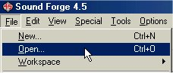

Go to the path where you saved the audio track you extracted, click on the file and press Open (Make sure the are checked exactly like in the screen shot presented!).
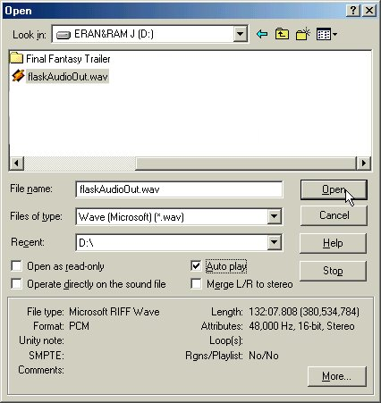

Wait until the file loading is finished, and go to Process→Normalize
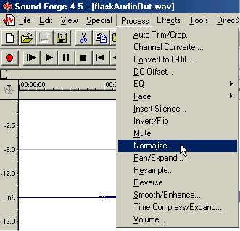

Choose Normalize RMS to -6 dB (notice - very loud!)
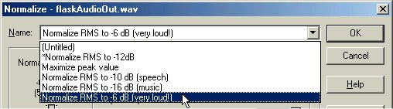

and then make sure that the near the Use equal loudness contour is checked.
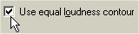
When you finish click OK and wait until the normalization will finish.
When the normalization is finished, save the file and close the program.

Virtual Dub
To combine the video file with the audio file, we'll open the video file in Virtual Dub.
Go to File→Open video file (or press CTRL+O) and open (only) the compressed video file you created with Flask MPEG previously.

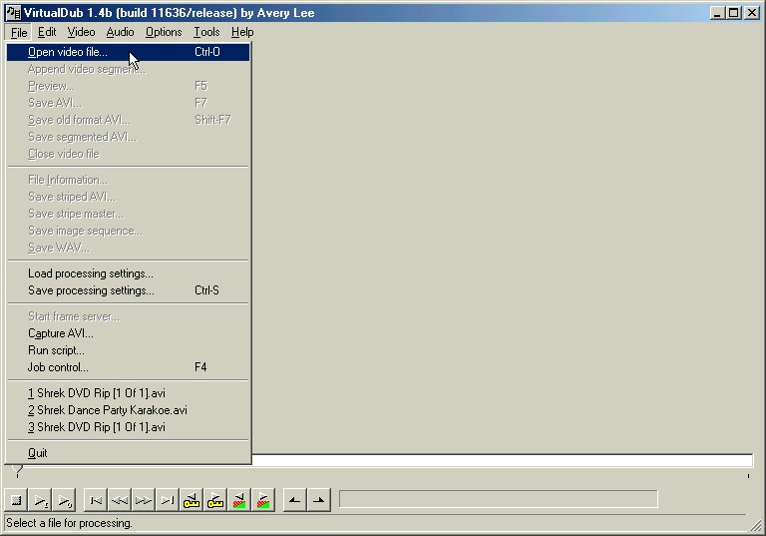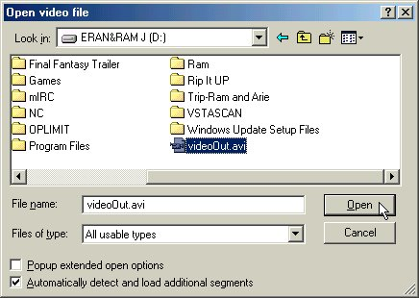

Go to Video→Direct stream copy- this will combine the video as it is an won't harm its quality.
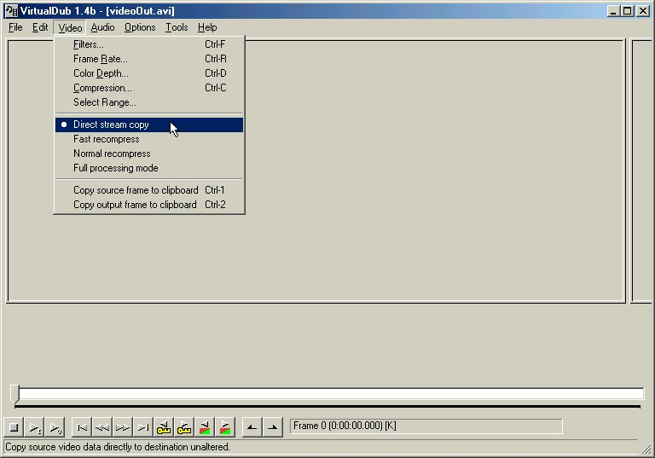
Now go to Audio→Wav audio and choose the audio file we have previously normalized.
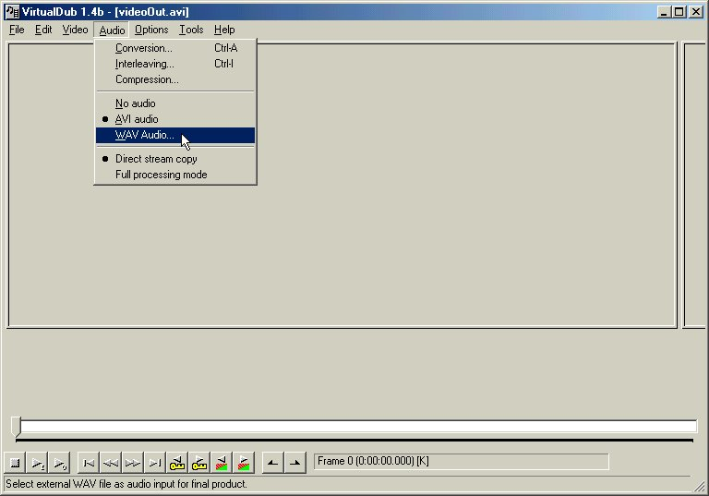

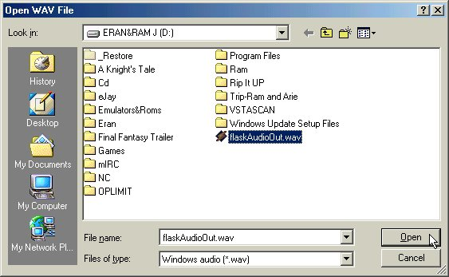
Go to Audio→Full processing mode- this will compress the audio.
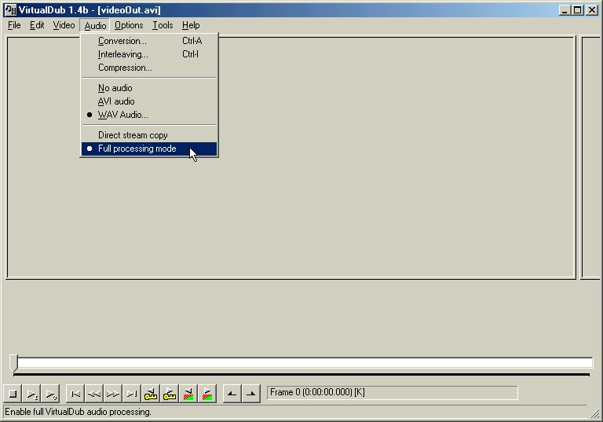

Press CTRL+A and check High quality (highlighted with blue in the screen shot) and remember the Audio frequency (highlighted with green)- we'll need it later.

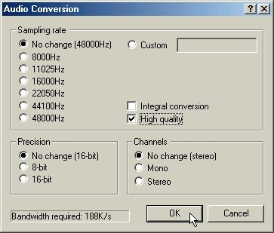
Go to Audio→Compression 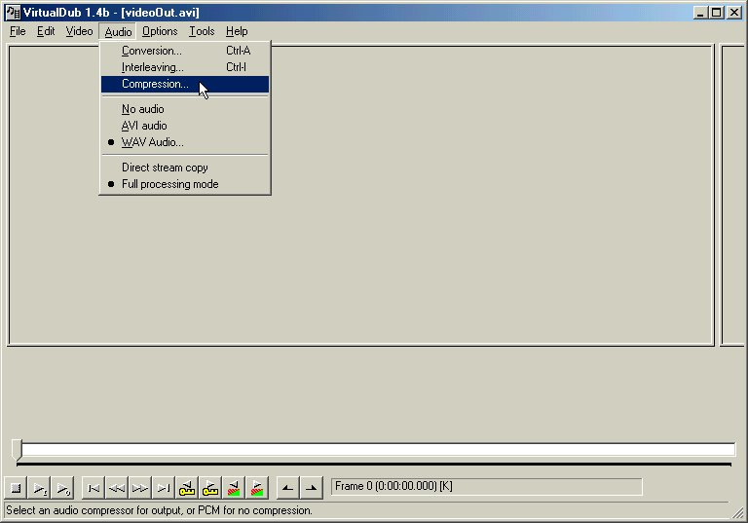

Choose MPEG Layer-3 (highlighted in green).
Check the Show all formats.
Choose the kBit/s as you calculated in the Ecuador's AVI Bitrate Calculator 2-for example 96 kBit/s.
Choose the Audio frequency as you previously wrote -for example 48,000 Hz.
So finally, if you got (for example) 96 kBit/s and frequency of 48,000 you'll choose 96 kBit/s, 48,000 Hz Stereo(highlighted in blue).
Now press OK.
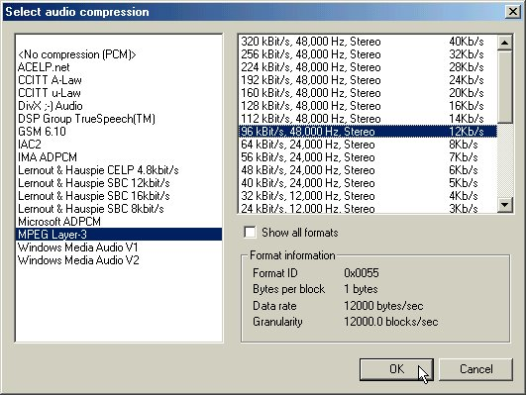
If you want to cut the movie when the credits start do the following:
Press on |< (highlighted with blue) and press on the (keyboard)Home button.
Then scroll the timeline till where you want the movie to be cut and press the (keyboard) End button.
It will look like this:
Now we're finished. press the F7 button on the keyboard, and save the movie (This should take between 20 to 70 mintues).
That's it! the saved file is your combined movie and is at great quality!
The End

